Untuk menghubungkan aplikasi kita pada sebuah API, kita memerlukan 3 hal :

1. Class sebagai model
2. Factory Method untuk maping dari json object ke class yang kita buat
3. Method untuk memanggil API

Tambahkan plug-in http di pubspec.yaml :

http: ^0.12.2 // angka itu versi (di dalam dependencies) // sejauh ini 0.12.2 versi 2021 latest

lalu import http dart nya.

Souce GET :

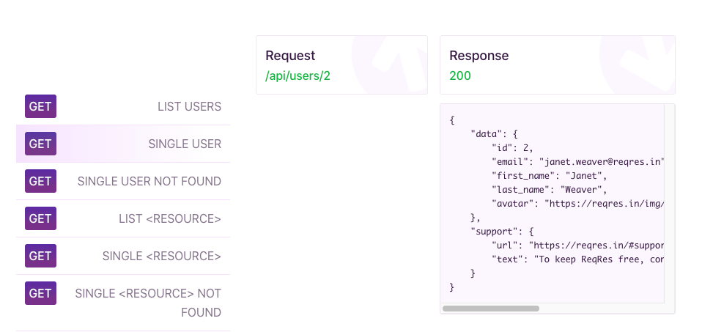

Source POST:

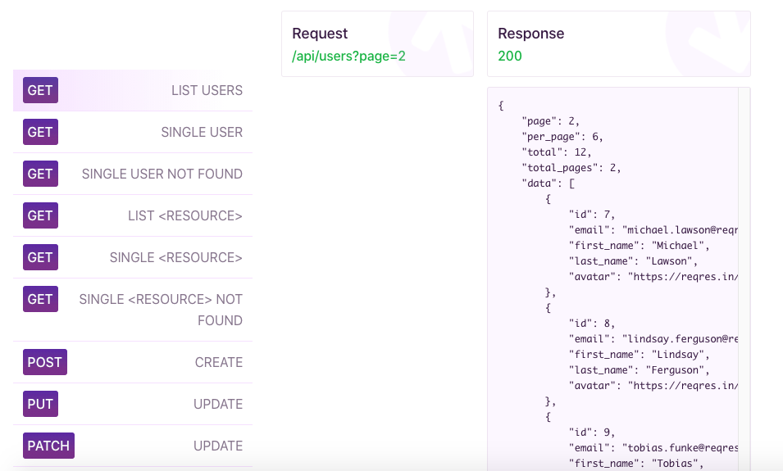

Source GET List (Kumpulan Data):

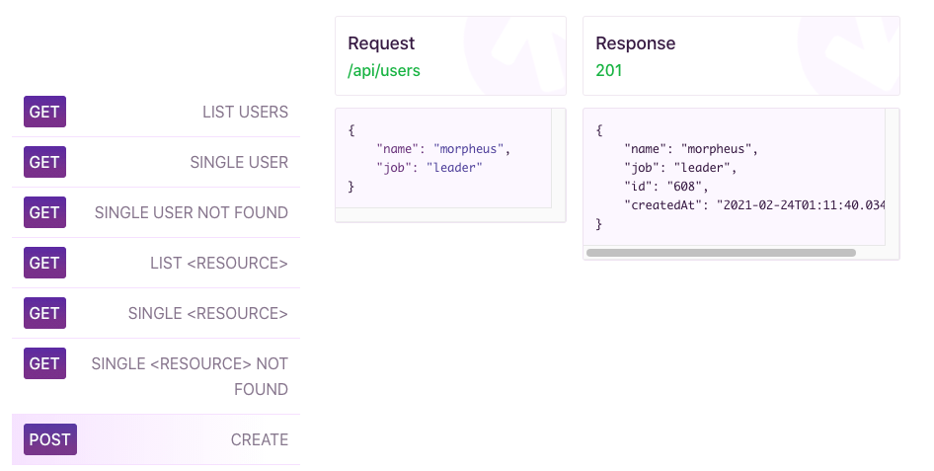

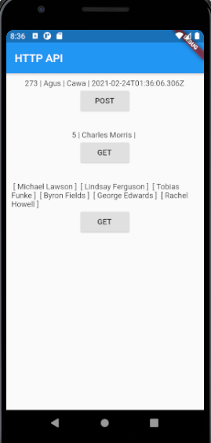

Main.dart

import 'package:belajar_flutter/post_result_model.dart';

import 'package:belajar_flutter/user_model.dart';

import 'package:flutter/material.dart';

void **main**() {

**runApp**(**MyApp**());

}

class **MyApp** extends **StatefulWidget** {

@override

**_MyAppState** **createState**() => **_MyAppState**();

}

class **_MyAppState** extends **State**<**MyApp**> {

**PostResult** postResult;

*// deklarasi dlu awalnyo supayo otomatis null awalny*

**User** user;

**String** output = "Belum ada kumpulan Data";

@override

**Widget** **build**(**BuildContext** context) {

return **MaterialApp**(

home: **Scaffold**(

appBar: **AppBar**(

title: **Text**("HTTP API"),

),

body: **Column**(

children: [

**Container**(

margin: **EdgeInsets**.**fromLTRB**(10, 10, 10, 20),

child: **Column**(

mainAxisAlignment: **MainAxisAlignment**.start,

children: [

**Text**((postResult != null)

? postResult.id +

" | " +

postResult.name +

" | " +

postResult.job +

" | " +

postResult.created

: "Tidak ada Data"),

**RaisedButton**(

onPressed: () {

**PostResult**.**connectToAPI**("Agus", "Cawa").**then**((value) {

postResult = value;

**setState**(() {});

});

},

child: **Text**("POST"),

)

],

),

),

**Container**(

margin: **EdgeInsets**.**fromLTRB**(10, 10, 10, 20),

child: **Column**(

mainAxisAlignment: **MainAxisAlignment**.start,

children: [

**Text**((user != null)

? user.id + " | " + user.name + " | "

: "Tidak ada Data"),

**RaisedButton**(

onPressed: () {

**User**.**connectToAPI**("5").**then**((value) {

user = value;

});

**setState**(() {});

},

child: **Text**("GET"),

)

],

),

),

**Container**(

margin: **EdgeInsets**.**fromLTRB**(10, 10, 10, 20),

child: **Column**(

mainAxisAlignment: **MainAxisAlignment**.start,

children: [

**Text**(output),

**RaisedButton**(

onPressed: () {

**User**.**getUsers**("2").**then**((users) {

output = "";

for (**int** i = 0; i < users.length; i++)

output = output + " [ " + users[i].name + " ] ";

**setState**(() {});

});

},

child: **Text**("GET"),

)

],

),

)

],

)));

}

}

Post_result_model.dart

import 'dart:convert';

import 'package:http/http.dart' as http;

class **PostResult** {

*// ini class untuk maping RESPONES dari api server*

**String** id, name, job, created;

*// pake id name job created ni dari API server ny reqres.in*

*// kareno emang cakitu response dari sano ny biso di cek di web ny*

*// buat constructor ny*

*// this.id dll tu sm be cak self.id, self.name dll*

**PostResult**({this.id, this.name, this.job, this.created});

*// factory berfungsi untuk membuat si object dari postResult*

*// tapi membuat nya itu hasil mapping dari JsonObject*

factory **PostResult**.**createPostResult**(**Map**<**String**, **dynamic**> object) {

*// kenapa String, dan dnymaic karena dilihat dari kembalian dari webservice*

*// reqres.in dia "string" : "value" , value nya gak tentu kadang String kadang int*

return **PostResult**(

id: object['id'],

name: object['name'],

job: object['job'],

created: object['createdAt'] *// createdAt dari reqres.in ny*

);

}

*// method untuk menghubungkan aplikasi kita ke API*

static **Future**<**PostResult**> **connectToAPI**(**String** name, **String** job) async {

**String** apiURL =

"https://reqres.in/api/users"; *// masukan URL API YANG DIPERLUKAN !*

var apiResult = await http.**post**(apiURL, body: {

*// http berfungsi untuk get data nya dengan protokol http, tapi berformat string*

"name": name,

"job": job,

});

var jsonObject =

json.**decode**(apiResult.body); *// nanti klik import dart convert ya*

return **PostResult**.**createPostResult**(jsonObject);

}

}

User_model.dart

import 'dart:convert';

import 'package:http/http.dart' as http;

class **User** {

**String** id, name;

**User**({this.id, this.name});

factory **User**.**createUser**(**Map**<**String**, **dynamic**> object) {

return **User**(

id: object['id'].**toString**(),

name: object['first_name'] + " " + object["last_name"]);

}

static **Future**<**User**> **connectToAPI**(**String** id) async {

**String** apiURL = "https://reqres.in/api/users/" + id;

var apiResult = await http.get(apiURL);

var jsonObject = json.**decode**(apiResult.body);

var userData = (jsonObject as **Map**<**String**, **dynamic**>)['data'];

return **User**.**createUser**(userData);

}

static **Future**<**List**<**User**>> **getUsers**(**String** page) async {

**String** apiURL = "https://reqres.in/api/users?page=" + page;

var apiResult = await http.get(apiURL);

var jsonObject = json.**decode**(apiResult.body);

**List**<**dynamic**> listUser = (jsonObject as **Map**<**String**, **dynamic**>)['data'];

**List**<**User**> users = [];

for (**int** i = 0; i < listUser.length; i++)

users.**add**(**User**.**createUser**(listUser[i]));

return users;

}

}